For your information  REAL – Distribution  EAB/TBF  EAB/TBL  Checked:  EAB/TBF Peter Ökvist  EAB/TBY Jessica Östergaard  EAB/TBF Kjell Larsson | Receiver  REAL Project  EAB/FJL/SF Gunnar Peters  EAB/FJT/D David Wisell  EAB/FRL Paul Teder  LEAD Fast RRM

Downlink Link Adaptation Analysis - LTE Verizon Testbed
Abstract
The Verizon LTE FD0 testbed logs give a unique opportunity to look into detailed behavior of downlink link and rank adaptation. In this report some observations from TTI-level (1 ms) investigations on TTI are documented.
For on-off interference test cases, observations show that the current CQI-adjustment targeting 10 % BLER fails to utilize the interference reduction when lowering the interference. Performance is even worse in a 50 % load case compared to a 100 % load case, clearly indicating that the outer loop CQI adjustment is severely disturbed by pulsing interference, and needs modification.
Observations show that the outer loop adjustment follows the shadow fading of the channel closely. The result is that CQI adjustment for mobile UEs gets displaced to purely negative adjustments, resulting in an overly conservative choice of format, and poorly utilized channel capacity. This further suggests studies on potential improvements of the outer loop adjustment algorithm.
There is a significant difference in CQI adjustment between ranks. The difference between rank 2 codewords seems smaller. The need for rank specific CQI adjustment is therefore justified, while the need for codeword specific adjustment is less obvious.
The known HSDPA phenomenon with higher HARQ BLER for larger transport blocks is observed for LTE as well. For LTE, outer loop CQI-adjustment is observed to increase this behavior in certain cases.
Observations show that reporting timing of CQI and RI (Rank Indicator) reports was not chosen in a beneficial way in the testbed. This must be considered when choosing timing settings in the first product release.
The testbed link adaptation implementation gives periodic increases in block error rate, caused by broadcast and synchronization (PBCH/PSCH/SSCH) signaling stealing robustness. It is important that proper consideration of PBCH/PSCH/SSCH is done already in the first product release.

Contents
1 Introduction 3
2 LTE Testbed 3
3 Downlink Link Adaptation in LTE Testbed 5
4 Test Cases 9
5 Effect of inter-cell interference 9
5.1 Test description 10
5.2 Test results 11
5.3 Simulation with varying channel 13
6 CQI reporting 16
6.1 RI and CQI reporting timing 16
6.2 CQI age and reporting interval 17
6.3 CQI vs Rank 20
7 BLER observations 23
7.1 Skewed BLER 23
7.2 Periodic BLER 25
8 Outer loop CQI adjustment algorithm 27
8.1 Outer loop adjustment in the testbed 27
8.2 CQI adjustment per rank and codeword 29
9 Conclusions 32
10 Further work 33
11 References 34
12 Appendix 35
12.1 Transport formats in LTE testbed 35
12.2 Additional graphs from inter-cell interference tests 37

Introduction
The LTE FD0 testbed has been extensively tested in Verizon field trials. Even rather advanced features not planned until later releases of the product has been implemented and tested, for example closed-loop precoding with rank adaptation and frequency selective scheduling. The FD0 testbed is also to a large extent 3GPP-compliant on layer 1 and 2.
Overall performance like handover delay, system and user throughput has been reported earlier. However, detailed logging of feature behavior has not been studied and documented much. Since the testbed has very good logging facilities enabling analysis of detailed 1 ms correlated measures and algorithm tracking, for example of HARQ, it is of great interest to utilize this possibility to get insight in real LTE algorithm behavior. This knowledge can be useful for product algorithm design and parameter settings, simulator modeling and possibly also for standard improvements.
In this report the Verizon testbed logs have been analyzed from a downlink link adaptation point of view including rank adaptation, outer loop CQI-adjustment and HARQ behavior. It is not a complete overview of the testbed link adaptation and Verizon logs, but rather a documentation of observations that can be of interest.
Note, that more detailed information about the test cases presented in this report is available in Section Error: Reference source not found.

LTE Testbed
The LTE testbed is actually a series of testbeds, the Alpha 0.5, Alpha 1.0, Alpha 1.5 and now the latest FD0 testbed. These testbeds are prototypes of an LTE system with different functions and features supported. They are developed using different (in time) snapshots of the 3GPP LTE specifications and therefore have different degrees of compliance.
For the FD0 testbed, which is the testbed considered in the current report, there is rather good 3GPP compliance. The FD0 specifications were written with the 3GPP specifications from March 2008 as base, with best guesses added of the missing pieces. The major deviations from Release 8 of the 3GPP specifications are
- Physical layer
  - Transport format tables and signaling,
  - CQI definition,
  - DCI details,
  - PDCCH search space,
  - No PHICH (only adaptive retransmissions);
- MAC
  - No uplink buffer status reporting,
  - Power headroom report always included in PUSCH transmissions;
- RRC
  - Message contents and formatting.
Among the above deviations, it is only the deviations in CQI definition and the transport format tables that are related to DL link adaptation. These deviations are discussed in Section 3.
FD0 is a 10 MHz FDD system supporting
- 2x2 MIMO,
- 8 UEs,
- 12 eNBs with one cell each,
- One MME and one GW.
The UE and eNB were built by the testbed organization while the MME and the GW were pre-commercial nodes.
The maximum DL peak rate is 75 Mbps and the system supports the modulation schemes QPSK, 16 QAM and 64 QAM in DL. FD0 also supports the transmission modes:
- TX diversity,
- Open-Loop Spatial Multiplexing (OLSM) with large-delay CDD, and
- Closed-Loop Spatial Multiplexing (CLSM) with sub-band PMI (PMIs according to 3GPP).
Two Channel State Information (CSI) reporting modes may be configured:
- periodic reports: Rank Indicator (RI) and wide-band CQI are reported periodically on PUCCH (or PUSCH if the UE is scheduled in UL). The reporting period used in all tests considered in this report is 40 ms, i.e. every 40 ms a new RI respectively wide-band CQI are transmitted.
- scheduled reports: RI and one or two wide-band CQI together with sub-band information are reported on PUSCH upon request from the eNB. The sub-band information is either sub-band CQI or sub-band PMI. The target reporting period is 5 ms in all tests considered.
The TX diversity and OLSM modes may operate either with periodic reports or with scheduled reports (but not both). In case of scheduled reports a report consists of RI, one wide-band CQI and sub-band CQI differentials (offsets to the wide-band CQI). The CLSM mode only operates with scheduled reports, where the report contains RI, one wide-band CQI per codeword and sub-band PMIs.

Downlink Link Adaptation in LTE Testbed
In Release 8 of the LTE standard the Modulation and Coding Scheme (MCS) is signaled to the UE using a 5-bit value I_{MCS}, see Section 7.1.7 in [1]. This value determines the modulation and code rate used. Together with the Resource Block (RB) allocation the corresponding Transport Block Size (TBS) can be calculated. In the LTE testbed FD0, MCS is signaled using a 6-bit value called Transport Format Index (TFI). The design of the TFI is such that there are some pairs of TFIs that give the same TB size but using different modulation. The (downlink) Link Adaptation (LA) for FD0 was designed to always use the TFI with the higher modulation order for these cases. This means that the LA algorithm was designed to prefer higher modulation order and lower code rate instead of lower modulation order and higher code rate, with the result that some of the TFIs are never used. Therefore, it is convenient to map the TFIs that can be used to a new index set. These resulting reduced indices are referred to as Reduced Format Indices (RFIs). The mapping between TFIs and RFIs is given by Table 1. All TFIs and RFIs are listed in Appendix 12.

Table 1: Mapping table between TFI and RFI together with corresponding modulation.
TFI | RFI | Modulation
0,1, …, 32 | TFI | QPSK
37, 38, …, 46 | TFI – 4 | 16QAM
51, 52, …, 60 | TFI – 8 | 64QAM
61 | 53 | QPSK
62 | 54 | 16QAM
63 | 55 | 64QAM
TFI 61-63 are special in the sense that they are only used for re-transmissions that can not be signaled with any of the standard TFIs. For example if the scheduled number of resource blocks has changed and does not longer support the block size needed for the retransmission. Therefore, TFI 61-63 signals that the TB size shall be the same as the original transmission, but a different modulation can be signaled if needed to fit the block size in the new resource allocation. These special TFIs are thus never used unless there is no other explicit TFI that can be used.
The basic LA algorithm in FD0 works as follows. The UE estimates the channel and reports a Rank Indicator (RI) and one (or two) wide-band CQI. The reported CQI maps to a TFI denoted TFI(CQI) (or, RFI(CQI) in the RFI domain) with an MCS that the UE estimates will give 10 % Block Error Rate (BLER). The LA algorithm selects the transmission rank equal to RI (i.e., no rank adjustment is used) and TFI_{Used} (or, RFI_{Used}) which is the TFI(CQI) plus an additional outer loop adjustment. Since the outer loop adjustment is designed to operate in the RFI domain, it is more convenient to describe the LA algorithm in this domain. The used RFI, (RFI_{Used}), may then be expressed as:
RFI_{Used} = floor(RFI(CQI) + RFI_{adj}),
where RFI_adj is the outer loop adjustment and floor(x) is rounding to nearest lower integer.
The outer loop adjustment is a simple jump algorithm [7] to keep the BLER at a target value (BLER_{target}). In the FD0 implementation of the jump algorithm RFI_adj is reduced by RFI_{step} for each received Negative ACKnowledgement (NACK) of a transmission and for each received (positive) ACKnowledgement (ACK) of a transmission it is increased by RFI_{step} / (1 / BLER_{target} - 1). Since the implementation allows for faster adjustment intervals than the ACK-NACK round-trip time (i.e. the time it takes from the transmission until the ACK-NACK is received), the RFI_{step} is kept small. To avoid wind-up effects the absolute value of RFI_{adj} is limited to RFI_{maxAdj}.
For all considered test cases, the following parameter values have been used:
- BLER_{target} = 0.1
- RFI_{step} = 0.1
- RFI_{maxAdj} = 10.
The parameter values result in that the adjustment is reduced by 0.1 for every NACK received and by approximately 0.011 for every ACK received.
There are three instances of the outer loop adjustment algorithm operatiing:
- One algorithm for rank 1 transmissions, and
- two algorithms for rank 2 transmissions (one for each codeword).
In case of Frequency-Selective Scheduling (FSS), LA is slightly more complicated. In this case, the CSI report consists of sub-band CQI differentials together with a wide-band CQI and a rank indicator. RFI_{Used} is calculated as:
RFI_{Used} = floor(RFI(CQI_{avg}(S)) + RFI_{adj}),
where CQI_{avg}(S) is the average CQI on the frequency band S for which the UE is scheduled on. The average is calculated as the wide-band CQI plus the linear average of the sub-band CQI differentials. Here, RFI(.) is extended by linear interpolation, so that it can handle real valued arguments. (Example: Let RFI(CQI_1) = RFI_1 and RFI(CQI_2) = RFI_2. For average CQI values CQI_avg in range [CQI_1, CQI_2] the function RFI(.) is defined as RFI(CQI_avg) = floor( (RFI_2 - RFI_1) / (CQI_2 - CQI_1) * (CQI_avg - CQI_1) + RFI_1 )).
Since RFI_{adj} is not available in the LTE testbed logs it is estimated as:
ΔRFI = RFI_{Used} - RFI(CQI).
For simplicity CQI is always a wide-band CQI. This means that the absolute value of ΔRFI may exceed RFI_{maxAdj} in some rare cases when FSS is used. In fact, in case of FSS the UEs tends to be scheduled on sub-bands with CQI better than the wide-band CQI. Thus, FSS tends to move the whole distribution of ΔRFI towards larger values. For the CLSM case there is a known bug that also may cause errors in the ΔRFI estimate when the rank switches. The bug results in an incorrect TFI selection for at most one TTI at each rank switch.
Table 2 shows that the CQI definition is quite close to 3GPP; the difference in code rate is within ± 7 % [5]. The largest difference is that CQI 14 and 15 are mapped to the same TFI. CQI = 15 shall, according to the FD0 specification, be reported when the UE estimates that the highest TFI (60) may be used even if the transmit power is reduced by 2 dB. However, it is not clear how this was implemented. There may be a small difference between CQI = 14 and CQI = 15.

Table 2 Mapping table between CQI and TFI/RFI with code rate per CQI value depending on the number of symbols for PDCCH. The last column gives the corresponding 3GPP code rate values.
CQI | TFI | RFI | Code rate |  |  | Code rate (3GPP)
 |  |  | #symbols for PDCCH
 |  |  | 1 | 2 | 3
1 | 1 | 1 | 0.074 | 0.078 | 0.076 | 0.076
2 | 8 | 8 | 0.121 | 0.125 | 0.123 | 0.117
3 | 14 | 14 | 0.183 | 0.191 | 0.187 | 0.188
4 | 21 | 21 | 0.297 | 0.310 | 0.304 | 0.301
5 | 27 | 27 | 0.45 | 0.470 | 0.462 | 0.438
6 | 31 | 31 | 0.594 | 0.621 | 0.609 | 0.588
7 | 38 | 34 | 0.366 | 0.382 | 0.375 | 0.369
8 | 42 | 38 | 0.483 | 0.504 | 0.495 | 0.479
9 | 45 | 41 | 0.594 | 0.621 | 0.609 | 0.602
10 | 51 | 43 | 0.455 | 0.475 | 0.467 | 0.455
11 | 54 | 46 | 0.560 | 0.585 | 0.575 | 0.554
12 | 56 | 48 | 0.644 | 0.672 | 0.660 | 0.650
13 | 58 | 50 | 0.739 | 0.772 | 0.759 | 0.754
14 | 60 | 52 | 0.849 | 0.887 | 0.871 | 0.853
15 | 60 | 52 | 0.849 | 0.887 | 0.871 | 0.926

Test Cases
Test cases investigated in this report are listed in Table 3.
Table 3 Investigated test cases
No. | Detailed Test Descriptions | Actual Complete | TOTAL UE
PH3-CAPF-202i | With Frequency Selective Scheduling active, measure throughput with available UDP Users in one sector. Two users in GOOD SNR, four users at Medium SNR and two users at Poor SNR location with "High" UL/DL Interference is present in system. Adaptive MIMO. 4 users moving (1 good, 2 medium and 1 poor) @ 30 km/h and the other four users remain stationery. Scheduled CQI reporting. | 2009-04-24 | 8 UE Total + UL/DL Interference
PH3-SCHU-624 | Fair time division scheduling test. .Two moving users, two users in GOOD SNR, two users at Medium SNR and two users at Poor SNR location with "High" UL/DL Interference? is present in system. Open loop spatial multiplexing. | 2009-03-18 | 8 UE Total
Test3_1805 | Baseline test. 8 stationary Ue, 4 Poor, 4 medium. Open loop spatial multiplexing, periodic CQI reporting | 2009-04-24 | 8 UE Total + UL/DL Interference
Inter-cell interference tests | 1 stationary UE. Closed-loop spatial multiplexing with scheduled CQI reporting with 5 ms target period. More test details is available in Section 5.1. | 2009-05-09  2009-05-14 | 1 UE + DL interference as specified for each test case

Effect of inter-cell interference
Most of the field tests were performed with either 0 % load or 100 % load in surrounding cells. This means that the inter-cell interference has been almost constant in time. However, a few tests with 50 % load where the interference is time-varying have been performed. Those are considered in this section.

Test description
Downlink interference in surrounding cells is generated using the so-called ghostUE function. In auto-mode, this function fakes a (ghost) UE which is scheduled (assuming no real UEs) on the whole frequency-band at randomized transmission time intervals (TTI, 1ms) such that the activity factor equals a configurable load value. In case of 50 % load, the ghostUE is thus scheduled 50 % of the time.
There is also a fixed-mode (actually a debug-mode) of this function in which it is possible to control which part of the frequency-band the ghostUE is scheduled on. However, in the fixed-mode the ghostUE always has 100 % activity.
The tests are performed with one test UE, continuously scheduled on the whole frequency band, in a rather good position, approximately 14 dB SINR for transmit diversity at 100 % load. The transmission mode is closed-loop MIMO with sub-band PMI for which;
- at rank 1, a wide-band CQI and nine sub-band PMIs are reported,
- at rank 2, two wide-band CQIs (one for each codeword) and nine sub-band PMIs are reported.
Four test cases were performed with different ghostUE setup:
Test 1 (No ghostUE): No ghostUE (and no real UEs) are active in surrounding cells. The only energy transmitted in surrounding cells is downlink reference symbols and system information.
Test 2 (100 % load): GhostUEs are active 100 % of the time transmitting on the whole frequency band.
Test 3 (50 % time): GhostUEs are active 50 % of the time transmitting on the whole frequency band when active.
Test 4 (50 % frequency): GhostUEs are active 100 % of the time but on half the frequency band. The used frequency band is fixed during the complete test. Note that this was no attempt to produce realistic interference, but only performed for comparison.
All four tests were performed on the same date, shortly after each other and without moving the UE. The channel conditions during the four tests should thus be comparable (apart from the interference).
It should be noted that the cells are not time synchronized and that the reference symbols are shifted depending on physical cell identity. This means that the inter-cell interference on the reference symbols comes most likely from data symbols in surrounding cells.

Test results
Throughput results for the four tests are shown in Figure 1 and estimated SINR for transmit diversity and Open-Loop Spatial Multiplexing in Figure 2. Notice that Test 3 (50 % time) gives essentially the same performance as the Test 2 (100 %), but the estimated SINR is significantly higher for Test 3 (50 % time) than for Test 2 (100 %). In fact, estimated SINR for Test 3 (50 % time) is almost as high as in Test 4 (50 % frequency), but the throughput for Test 3 (50 % time) is much lower than in Test 4 (50 % frequency). Thus, even though the channel is on average significantly better for Test 3 (50 % time) than in Test 2 (100 %) the system is not able to utilize it.
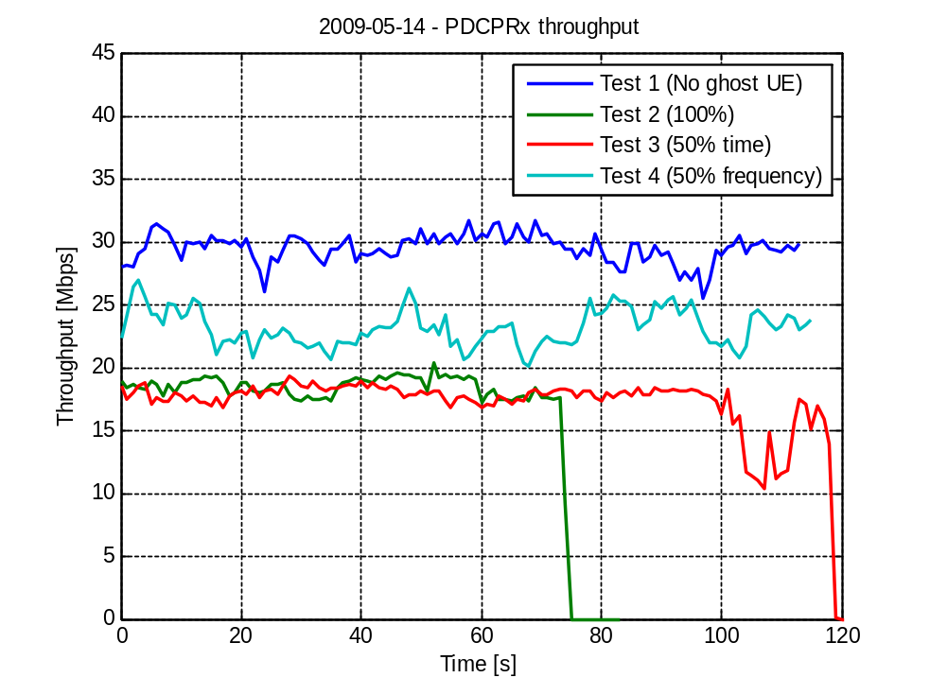
Figure 1 Tests on 2009-05-14. Throughput versus time for different inter-cell interference scenarios.

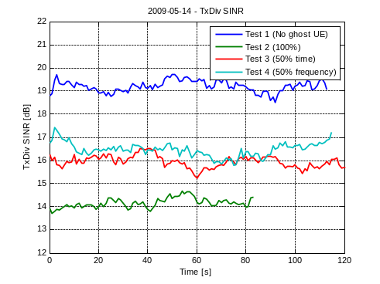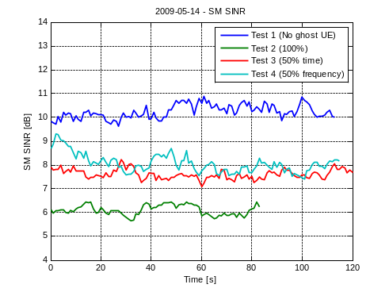
Figure 2 Tests on 2009-05-14. Estimated SINR values versus time for different inter-cell interference scenarios.

Another observation is that the outer loop adjustment differs between Test 2 (50 % time) and Test 3 (100 %). Figure 3 shows a comparison of the outer loop adjustment for each codeword for the first transmission attempt of rank 2 transmission.

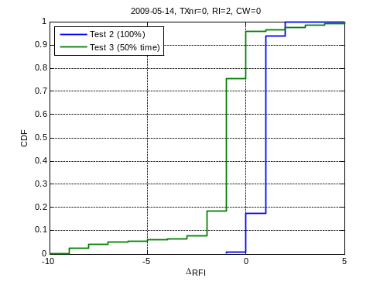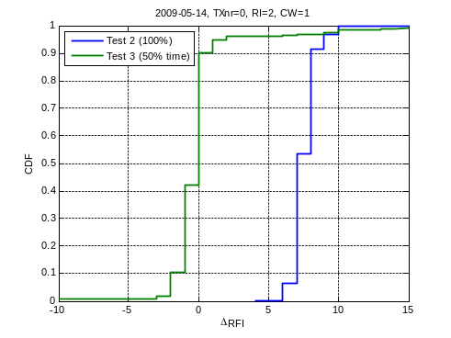
Figure 3 100 % load and 50 % load in time tests on 2009-05-14. CDFs of outer loop adjustment for first transmission attempt and rank two transmissions.
Left figure: CDF of outer loop adjustment in RFI scale for code word 0. Right figure: CDF of outer loop adjustment in RFI scale for code word 1.

Notice first the large positive adjustment for codeword #1 for Test 2 (100 %). The channel seems to be under-estimated for codeword #1 in Test 2 (100 %). Hence, there is a potential to get even better performance for the 100 % load case. The channel quality estimation for codeword #0 seems to be pretty accurate; there is just a slight positive adjustment. It should be noted that this large adjustment difference between the two codewords cannot be explained by successive interference cancellation since this feature is not supported in FD0. For the interested reader the outer loop adjustment CDF for rank 1 transmission is shown in Figure 27 in Section 12.2.

For Test 3 (50 % time) the average adjustment level is close to zero for both codewords. Since the channel conditions, apart from the interference, should be approximately the same, one could expect a large positive adjustment for codeword#1 also in this test. But this is not the case.

Again for the interested reader, the larger back-off in the adjustment for codeword#1 (than for codeword#0) when going to 50% load (time varying) is also apparent in the tests performed on 2009-05-09, see Figure 28 in Section 12.2. However, the very large positive adjustment for codeword#1 for 100% load seen in the test performed on 2009-05-14 cannot be seen in the tests performed on 2009-05-09. Whether it is true for FD0 that codeword#1 always is hit harder by time-varying interference than codeword#0 is left un-answered.
Figure 4 further illustrates that the outer loop has a tough job. The figure shows BLER versus reported wide-band CQI and one can notice the skew BLER. Higher BLER for higher CQI values is clearly visible. Excluding CQIs with low use frequency, higher BLER is observed for CQI=12 when RI=1 and when RI=2 for CQI = 6 and CW=1. This is probably due to that the higher CQI originates from estimation of the channel quality when the interference is low. Then there is a high probability that the LA selects a too high transport format. The lower BLER for lower CQI is probably due to that channel quality was estimated at occasions with high interference. At transmission, the selected transport format sometimes matches the channel and sometimes it is too low. The resulting BLER will be lower than the 10 % target.
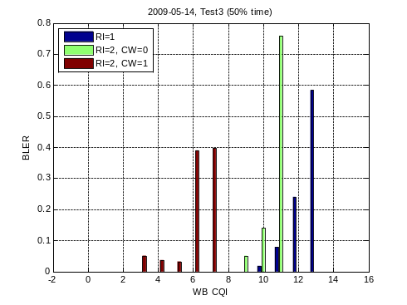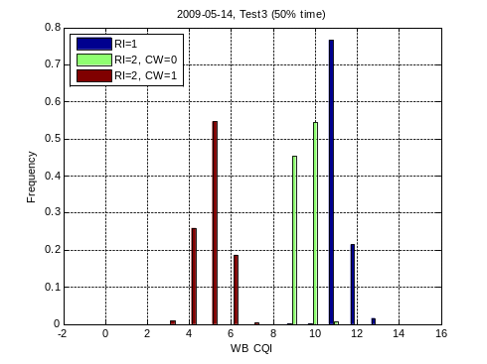
Figure 4 50 % load in time tests on 2009-05-14. Left figure: BLER per reported wide-band CQI used in LA decision. Right figure: Transmission frequencies per reported wide-band CQI used in LA decision (rank and code words are separated).
For the interested reader, there are a few additional graphs comparing Test 2 (100% load) and Test 3 (50% time) shown in Section 12.2.
To summarize, observations show that with on-off interference sources in surrounding cells, the current CQI-adjustment algorithm, targeting 10 % BLER, fails to utilize the interference reduction offered when interference load in surrounding cells is lowered. Section 5.3 describes an investigation where the CQI adjustment algorithm source code is used to simulate behavior for a varying channel. Section 5.3 further supports a suggestion that the algorithm needs to be updated, at least with some simple relaxation of the BLER target for scenarios with pulsed interference.

Simulation with varying channel
To illustrate the effect that a rapidly changing channel has on the outer loop CQI adjustment, simulations (simulator description below) with a rapidly changing channel were performed using the actual LTE testbed algorithms but with very simple radio channel and BLER models. The throughput is calculated as sum of sizes (per second) of correctly received transport blocks.
The radio channel was changed at certain distinct time intervals in a random manner. At the channel change intervals a new channel quality value RFI_{CH} (measured in RFI scale) was determined as
where RFI(CQI) is a mapping from a wide-band CQI to the RFI domain, RFI_{std} is the standard deviation in RFI of the channel quality and randn() is a normal distributed random value with zero mean and variance 1.
In the simulation three channel quality values were generated, one for rank 1, and one for each codeword for rank 2. The reported rank and wide-band CQI was selected to optimize throughput.
At each transmission the BLock Error Probability (BLEP) was calculated as:
Denote
RV: Redundancy version
RV_{Gain}: Paramter used to model incremental redundancy gain at retransmissions.
Offset: Parameter determining the slope of the BLEP curve.
Then, if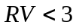 and the BLEP equals
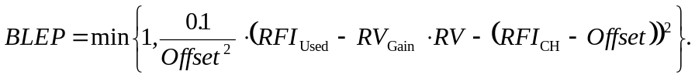
Otherwise BLEP=0.
This will result in 10 % BLER for 1st transmission if RFI_{Used} = RFI_{CH} and in exponential increase (decrease) of BLER for RFI_{Used} > RFI_{CH} (RFI_{Used} < RFI_{CH}). The parameter RV_{Gain} models the incremental redundancy gain at retransmissions.
Figure 5 shows the obtained BLEP versus used RFI with Offset = 5, RFI_{CH}= 27, RV_{Gain} = 10.
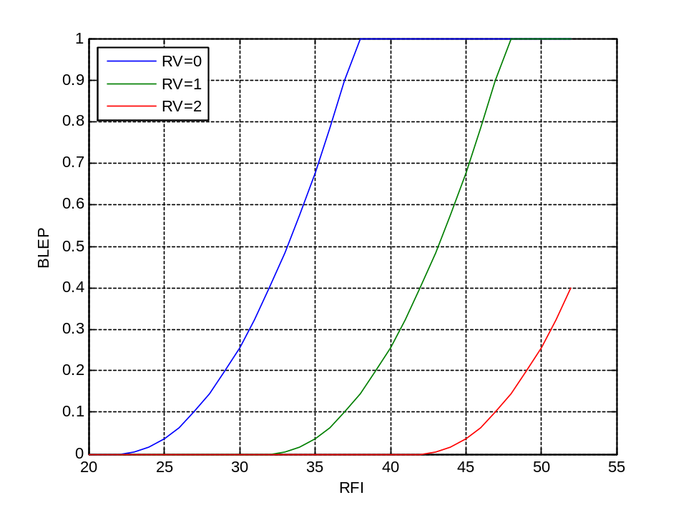
Figure 5 Simulation BLER model. BLEP versus used RFI with Offset = 5, RFI_{CH}= 27, RV_{Gain} = 10.
Simulations has been performed with RFI_{std} = 4 and 8 and with varying channel change interval in the range [10, 20, …, 80] ms, with enabled and disabled outer loop adjustment. For the BLEP model, Offset = 5 and RV_{Gain} = 10 was used. No deep analysis was done to tune the parameters to resemble the reality. The parameters were set to give a fairly rapid increase in BLEP when the used RFI goes above the value supported by the channel, and to get a fairly large incremental redundancy gain. The average RFI_{CH} was set to 56 (i.e., 12 in CQI scale) for rank 1 transmissions, and 51 (10 in CQI scale) for codeword#0 and 31 (6 in CQI scale) for codeword#1 for rank 2 transmissions. Figure 4 shows that these choices are just slightly higher than the average reported CQI values for Test 3.
In the simulator the CSI reporting is performed such that the estimated obtained throughput is maximized. Although it was not the purpose of these simulations to mimic the field tests, it is worth to note that the resulting reported CQI values were quite similar with respect to mean but the distribution was different. In fact, the variance of reported CQI turned out to be larger in the simulation than in Test 3. Whether this resembles a true difference in channel quality variances between the simulation and the field tests is left un-answered.
The result from the simulations is shown in Figure 6 where a large performance loss can be seen for RFI_{std} = 8 with outer loop enabled. For RFI_{std} = 8 and with the outer loop disabled there is almost no performance loss at the cost of higher BLER.
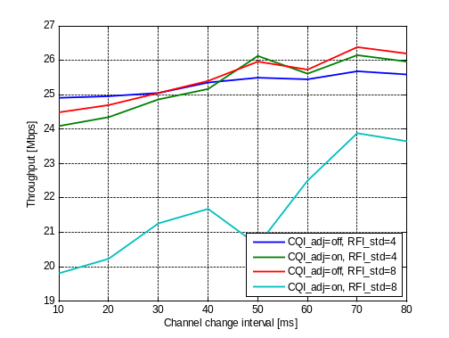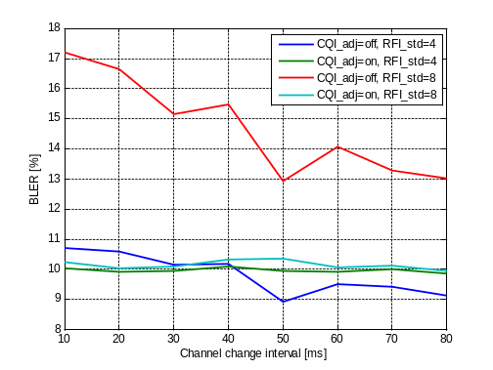
Figure 6 Simulation with LTE testbed algorithms. Left figure: Throughput versus channel change interval for outer loop adjustment turned on (i.e., CQI_adj=on) and turned off (i.e., CQI_adj=off) and for different variations in the channel change. Right figure: BLER versus channel change interval for outer loop adjustment turned on (i.e., CQI_adj=on) and turned off (i.e., CQI_adj=off) and for different variations in the channel change.

CQI reporting

RI and CQI reporting timing
The configuration of RI and CQI reporting timing on PUCCH can be made non-optimal from a delay perspective. Such an unlucky example is shown in Figure 7. 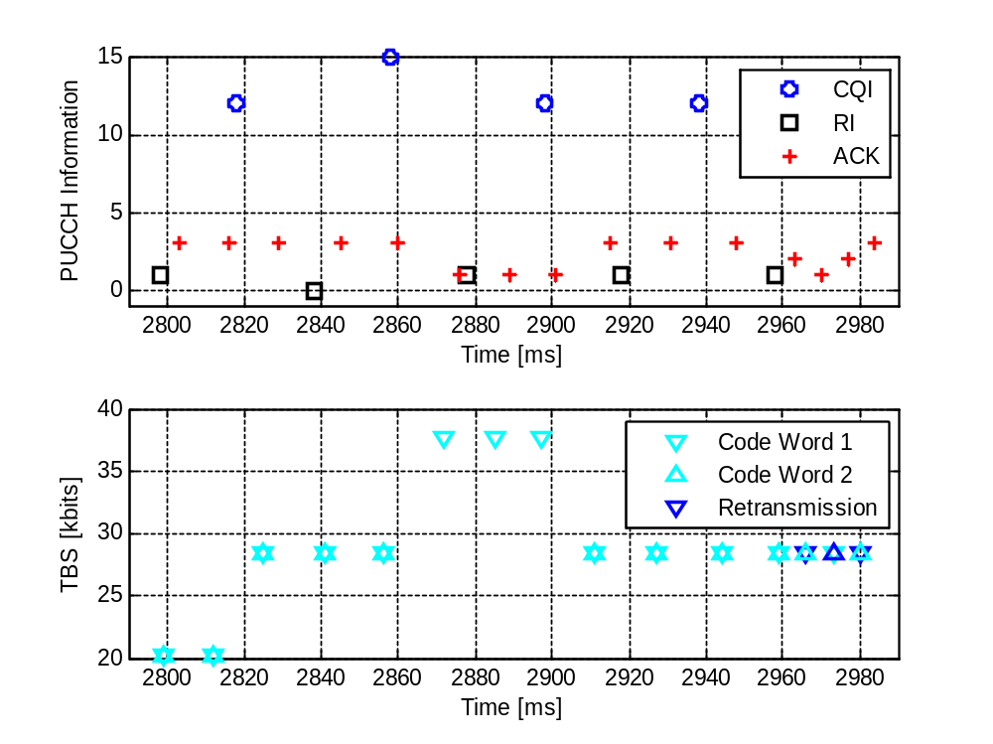
Figure 7 RI and CQI timing example, PID 2 in test case SCHU624 18/3
40 ms
40 ms
20 ms
Rank change delay
The CQI and RI reporting period was 40 ms in this test case and RI was configured to be reported 20 ms before CQI, N_{offset,ri}. The reason for the long CQI reporting period in this scheduling test case was to limit the PUCCH load to avoid control signaling problems. The UE reports CQI for the latest reported RI. The eNodeB receives first an RI which it cannot use immediately since it has no corresponding CQI. After receiving the corresponding CQI a rank change can take place. The rank change is then based on a measurement from the UE that has been aged by the CSI reporting delay, eNodeB processing delay, plus the additional unnecessary 20 ms. If N_{offset,ri} is instead set to 1 ms, a 19 ms shorter rank change delay is possible. This may however have other drawbacks on the CSI scheduling on PUCCH. The RI periodicity can be configured to be longer than the CQI periodicity, this delay increase will however still be there. Another possible solution to shorten this delay is that the eNodeB has an estimate of the CQI for non-reported rank and does not wait for the updated CQI.

CQI age and reporting interval
This section describes observations of how well the channel is predicted depending on the age of the used CQI value, or rather how block errors are affected by the CQI age. A CQI value has a certain “age”, i.e. the time between when it is measured and when it is used. This age thus depends on reporting procedures, processing time, and reporting intervals.. Note, that age 0 ms here refers to when the CQI value is first available for use, which means that at age 0 the value is approximately 6 ms old compared to when it was measured in the UE. Figure 8 shows the BLER as a function of CQI age for a moving UE (30 km/h). It can be seen that BLER shows a slight growing trend for increasing CQI age, for both rank 1 and 2. 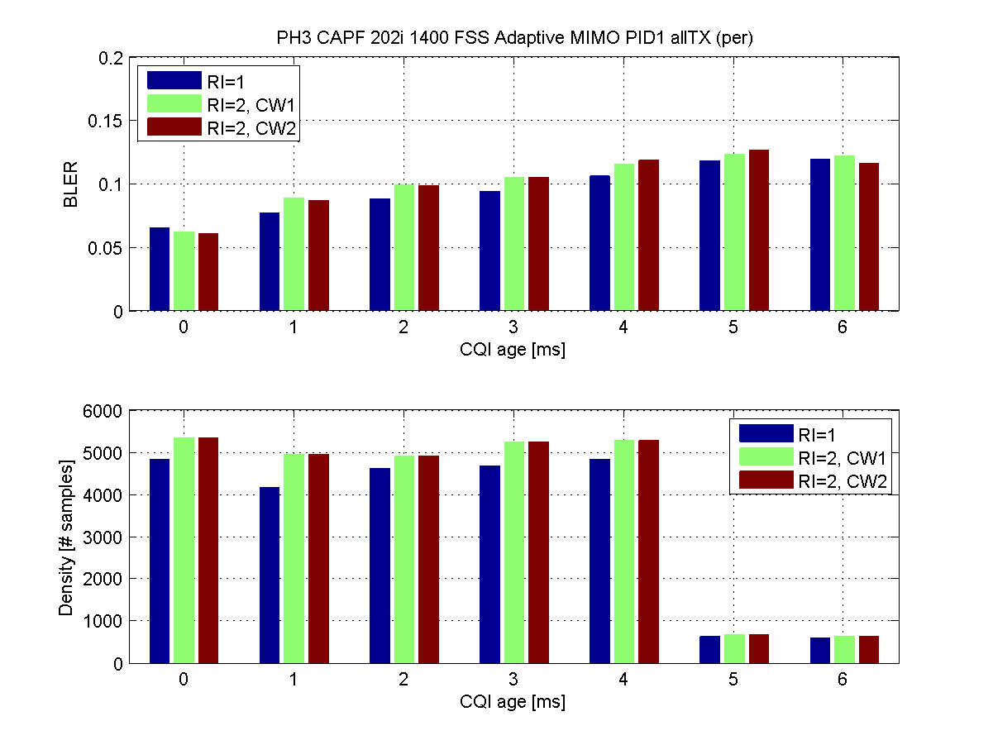
Figure 8 BLER as a function of CQI age, moving UE (30 km/h). BLER increases for older CQI values. In general, a new CQI value is received every 5 ms. Therefore, it is in this case rare with values older than age 4.
Since the UE is moving, the channel changes and the prediction of the channel quality becomes harder. The result is also affected by the outer loop CQI adjustment. Since the CQI adjustment algorithm tries to maintain a 10 % block error rate target, the choice of TFI is conservative for lower CQI age to still maintain an average 10 % despite the increased amount of BLER due to harder prediction at older CQI values.
For a stationary UE, it is easier to predict the channel for older CQI values. Figure 9 shows the same plot but for a stationary UE. This figure shows that the BLER is fairly constant at 10 %, regardless of CQI age. It can also be noted that the UE is situated in a spot where the radio environment does not allow rank 2.
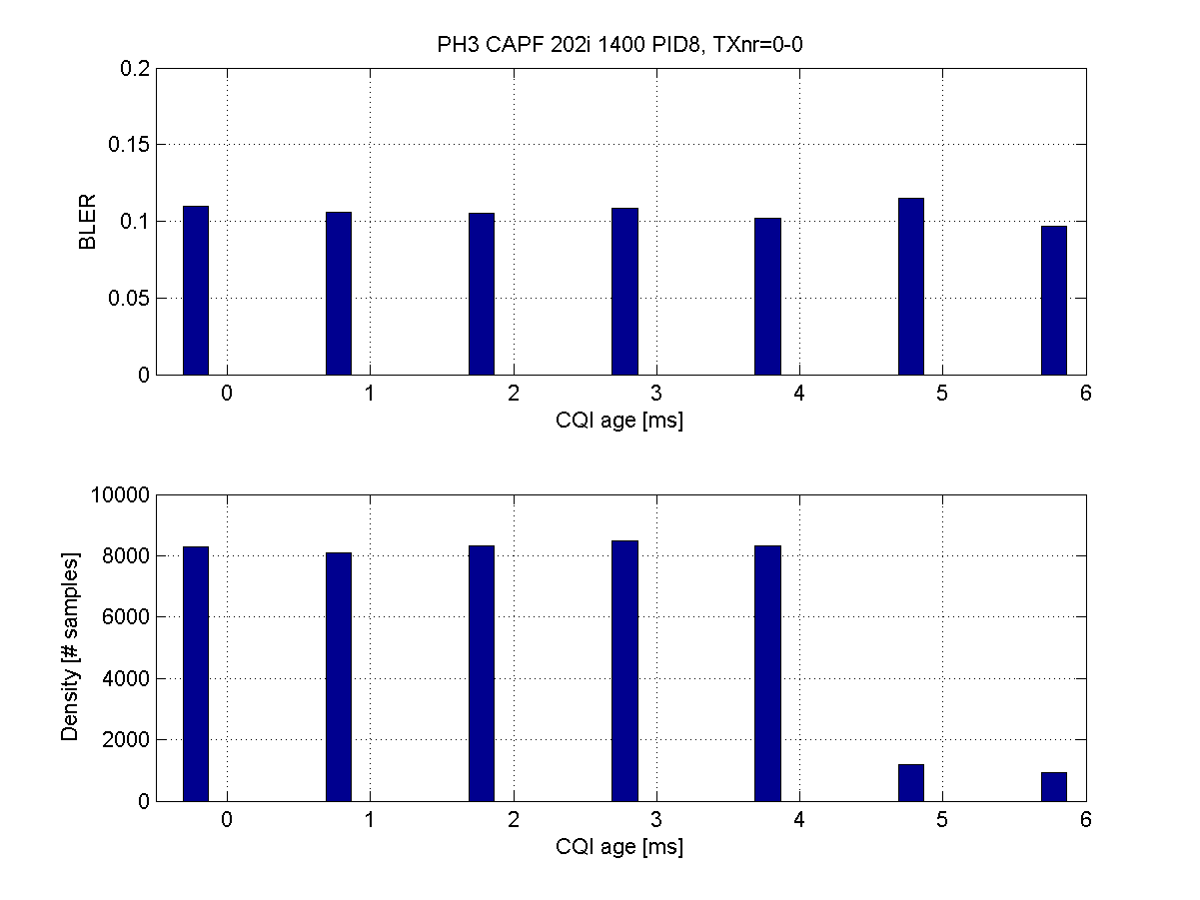
Figure 9 BLER as a function of CQI age, stationary UE. BLER is approximately 10 % for all CQI ages.
Figure 10 and Figure 11 show another view of the moving UE. Figure 10 shows the block error rate as a function of chosen TFI, for the CQI age span 0-2 ms. If this is compared to Figure 11, showing the same plot for CQI age span 3-5 ms, it is seen that the block errors increase for all TFI when the CQI age increases. Thus, for moving UEs, the channel is harder to predict when CQI values get older, leading to higher BLER.
The results in this section are based on test cases using 5 ms CQI reporting period. A few cases with larger reporting periods were also analyzed, but these results were heavily affected by the periodic BLER artefact (see Section 7.2). For example Figure 17 shows a CQI age plot for a case with 40 ms reporting period. This plot shows how the periodic BLER distorts other properties of CQI aging effects. However, in all the analyzed cases no suspicions of trends were raised. Currently, no major effects of CQI age is suspected even for larger reporting periods like 40 ms.
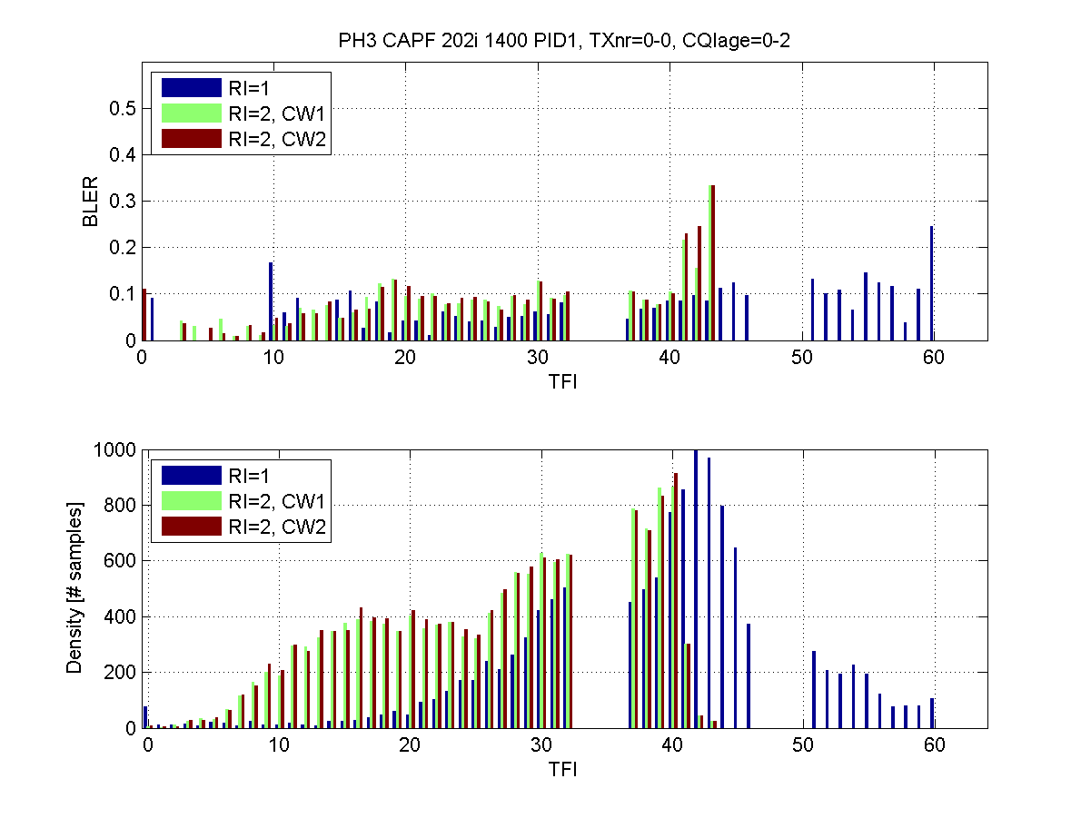
Figure 10 BLER as a function of TFI, moving (3 km/h) UE. CQI age between 0 and 2 ms. Only the first transmission, no retransmissions.
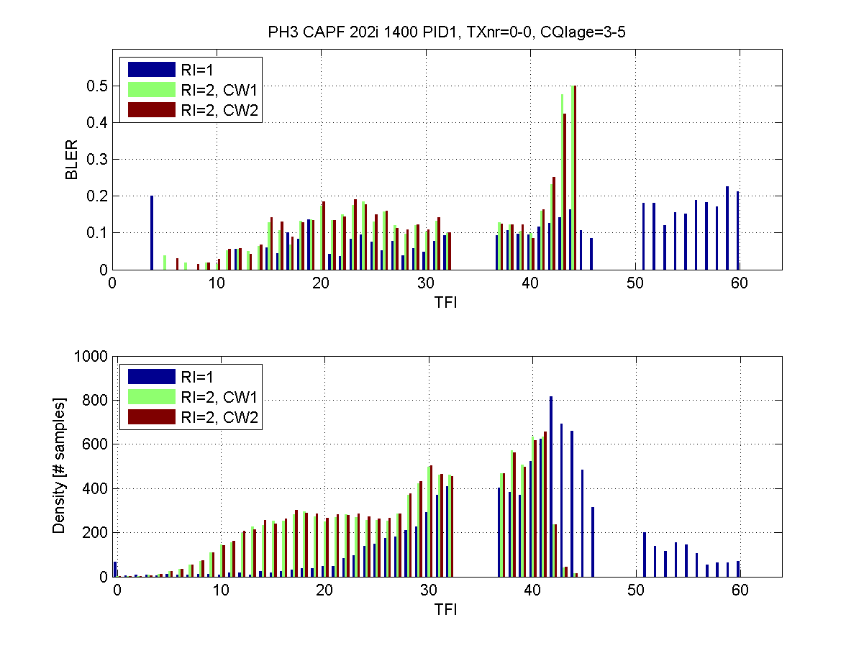
Figure 11 BLER as a function of TFI, moving (3 km/h) UE. CQI age between 3 and 5 ms. Only the first transmission, no retransmissions.

CQI vs Rank
The difference in CQI reported for rank 1 and rank 2 is interesting. CQI can be used for PDCCH link adaptation but since CQI reports quality for PDSCH (which can be of rank 2) the corresponding rank 1 quality must be estimated.
An estimate of the CQI for the other rank can also be of interest for the PDSCH. Examples are continuous CQI filtering for both ranks, and PDSCH link adaptation. One suggested method for HSPA is to assume a fixed inter-stream interference of 1 dB [3], and it is interesting to see if this can be used for LTE as well. An example of the LTE testbed rank-to-CQI relation for a stationary UE is shown in Figure 12.
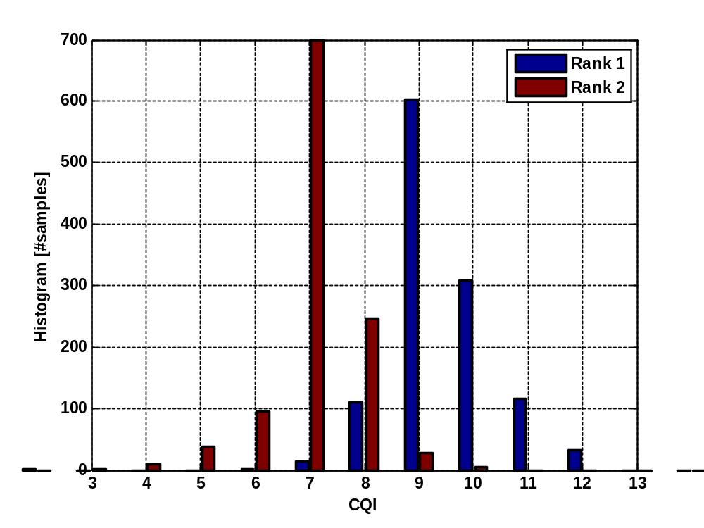
Figure 12 CQI histogram, PID 7 in test case SCHU624 18/3
The average difference in CQI is 2.3 CQI units which correspond to around 4.6 dB assuming one CQI unit equals 2 dB. Taking into account that the power is divided on two streams, (resulting in -3 dB or 1.5 CQI steps decrease), the remaining link quality difference is around 1.6 dB. This is close to the 1 dB inter-stream interference assumption in [3]. However, when inter-stream interference was investigated for two other UEs (using a sufficient amount of both ranks), the inter-stream interference was similarly estimated to 2.0 and 2.4 dB.
Further observations have been made in the SINR measured in the same stationary UE, see Figure 13. Here as well, the inter-stream impact seems to be larger than 1 dB, more than 3 dB in average in addition to the 3 dB caused by power splitting onto two streams. Around 15 % (85th percentile and above in the right figure) of the time the inter-stream interference seems to be 5 dB or more. A fixed offset may therefore not be a good estimate for an instant quality estimate. Possibly, the inter-stream interference impact is larger in the more orthogonal LTE access than in WCDMA/HSPA, but such a conclusion cannot be drawn from these results alone. UE receiver performance, specifically inter-stream suppression capability, also has a large impact (No successive interference cancellation in testbed).
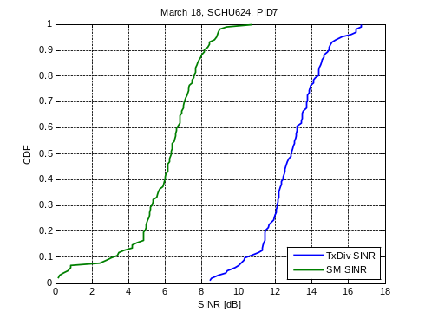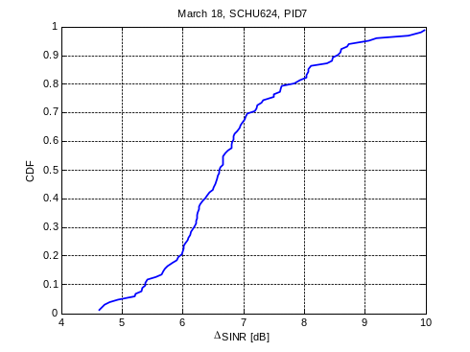
Figure 13 Average SINR measured in UE (1 s average), PID 7 in test case SCHU624 18/3. Left figure: rank 1 (Tx Div) and rank 2 (SM). Right figure: rank 1 minus rank 2.
Even larger differences in CQI can be seen when looking at shorter time intervals. CQI differences up to 4 CQI-units is observed indicating 5 dB inter-stream interference, see Figure 14.
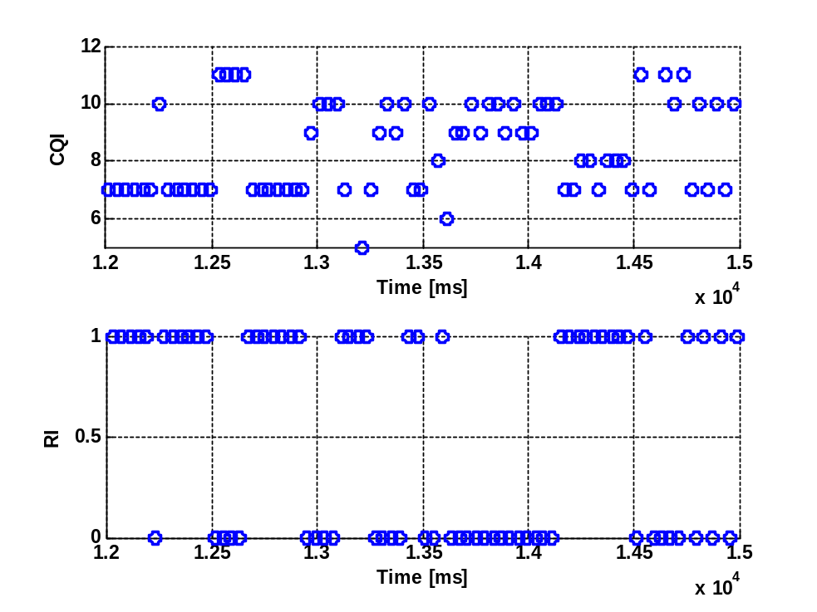
Figure 14 CSI report sequence, PID 7 in test case SCHU624 18/3. RI=0 rank 1, RI=1 rank 2.

BLER observations

Skewed BLER
Higher BLER for larger TBSs is a phenomenon that exists in practically all digital radio communication systems. Depending on the specific radio environment and the ability of the system to adapt to a varying channel quality, the magnitude will vary. For example, this was described for HSPA [2] where it was described how CQI reporting delay and CQI filtering (or rather lack thereof) create a skew distribution of block errors.
This is also visible for LTE, for example Figure 15 shows testbed measurement data with a skewed BLER distribution. The figure shows the BLER for all rank 1 transmissions for a single stationary UE. This example clearly shows the ramping BLER phenomenon.
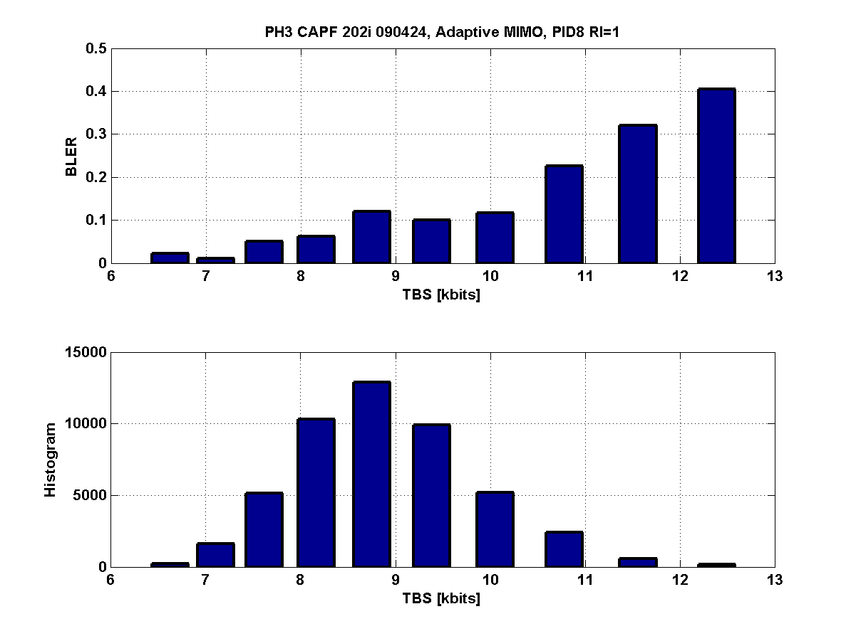
Figure 15 BLER as a function of TBS. This case clearly shows that BLER is higher at the top end of the distribution and lower at the low end.
The reason is the varying radio channel. Larger block sizes are chosen for higher radio qualities (higher CQI values). Due to the varying radio channel, the probability of experiencing a worse radio quality than “expected” depends on the reported radio quality. The higher quality measured and reported, the higher the probability that the quality will degrade and be lower when the block is actually transmitted over the radio interface (overestimation of channel quality).
The same contribution is made for the lower part of the radio quality distribution. Smaller block sizes are chosen when the quality is low, and the probability that the channel will be improved at the moment of transmission increases (underestimated channel quality). The effects of this phenomenon can be decreased by:
- decreasing the delay between measured quality and transmission (less likely that the channel has had time to change), ), at the expense of increased feedback overhead, and/or
- filtering of the measured quality values can help to predict what the channel will look like at the moment of transmission.
It should also be noted that the outer loop CQI adjustment algorithm contributes to this phenomenon. Even with a completely stationary channel, the jump algorithm will change CQI adjustment up and down based on received ACK/NACKs. Figure 16 shows an example of adjusted and unadjusted channel for two UEs, one moving and one stationary. The CQI has been normalized to the RFI domain to enable a comparison. This figure shows that for the moving UE (left figure), the adjusted channel and its variance is quite similar to the unadjusted. Thus, the adjustment algorithm does not add any variance. For the stationary UE the opposite is seen. The rightmost figure shows that the adjusted channel has a greater variance than the unadjusted, which means that the outer loop adjustment algorithm has contributed with more variance, which will increase the skewed BLER effect.
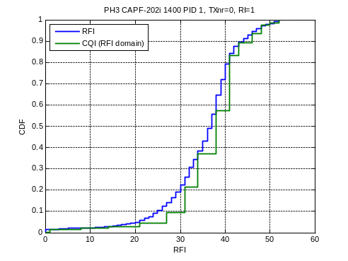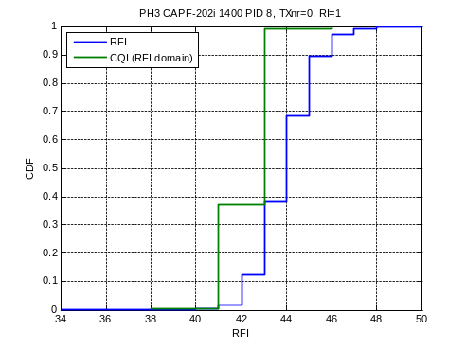
Figure 16 CDF of outer loop adjustment (rank 1, first transmission ) and CDF of CQI (in RFI scale) with mean subtracted. Left figure: PID1 moving UE.
Right figure: PID8 stationary UE.

Periodic BLER
Figure 17 shows a test case where increased block error rate occurs periodically every fifth millisecond. This is a result of how the testbed handles collisions with Physical Broadcast CHannel (PBCH), Primary Synchronization CHannel (PSCH) and Secondary Synchronization CHannel (SSCH) transmissions. PBCH is transmitted on subframe 0 and PSCH and SSCH are sent on subframe 0 and 5. To make room for these transmissions, redundancy bits are punctured from the original block size. Thus, every time a PBCH or PSCH/SSCH transmission is sent, the robustness of the downlink data transmission is reduced. This has been quick-fixed in the testbed by reducing the TFI number (increasing robustness) every time a PBCH/ PSCH/ SSCH transmission occurs. This reduces the problem, but the phenomenon is still visible in some test cases. How this is done in the first product release is unknown to us at this moment. It must be verified that this kind of solution is not used in the product!
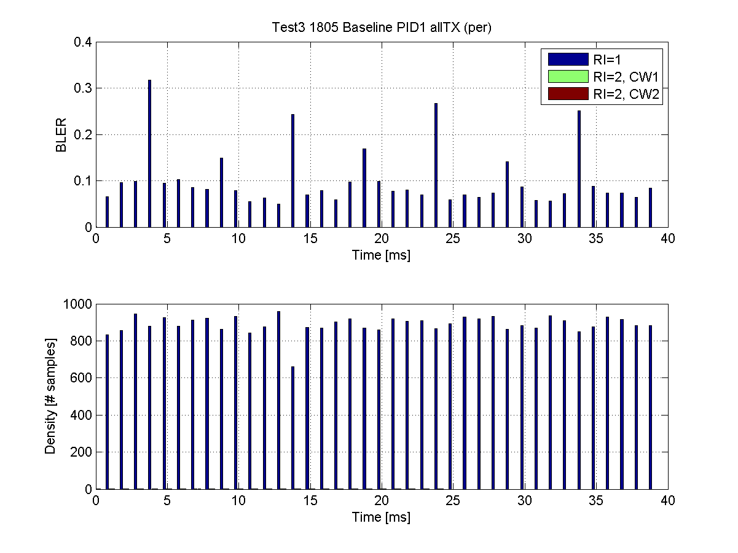
Figure 17 Test 3 1805 Baseline. Periodic BLER caused by PBCH/ PSCH/ SSCH stealing of redundancy bits.
Figure 18 shows that this problem can have a different effect on for example moving compared to stationary UEs.
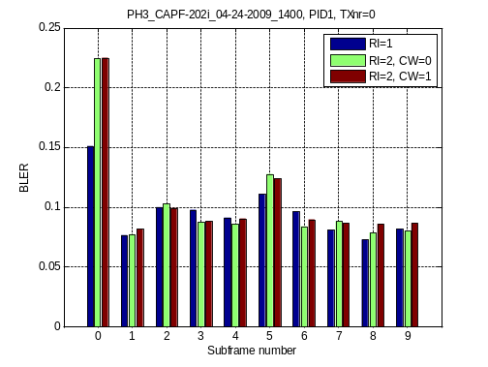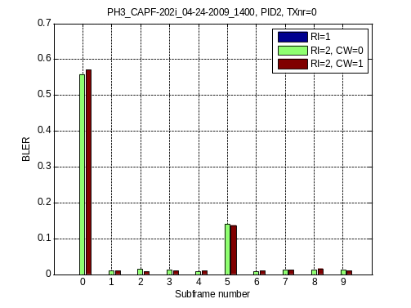
Figure 18 BLER versus subframe number. Left figure: PID1 moving UE.
Right figure: PID8 stationary UE. Both UE have similar radio conditions.
The left figure shows that for the moving UE the periodic BLER problem is somewhat buried by channel variation effects. The subframe 0 BLER raise is very clear, while subframe 5 shows a smaller impact. In the right figure it is seen that a stationary UE is much more affected. Since the channel has significantly smaller variations, the periodic BLER becomes a much larger problem. BLER on subframe 0 is very high, and this shows that the outer loop CQI adjustment has to compensate very hard to reach the average 10 % BLER, which degrades performance significantly also for the other (otherwise unaffected) subframes.
Figure 19 shows the difference obtained with the quick-fix implemented in the Testbed. It can be seen that the increased BLER for subframe 0 is removed. But, the increased BLER on subframe 5 is still there, since no compensation was done for PSCH/SSCH in subframe 5.
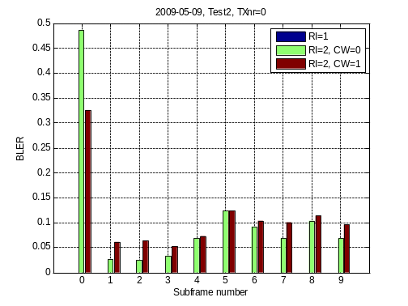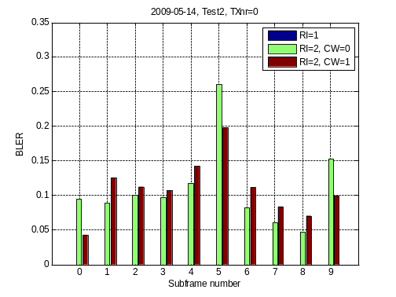
Figure 19 BLER versus subframe number. Left figure: Test without BCH compensation. Right figure: Test with BCH quick fix compensation. Both UE have similar radio conditions.

Outer loop CQI adjustment algorithm

Outer loop adjustment in the testbed
Figure 20 shows used RFI versus time per rank and codeword with color indication of successful or un-successful transmission. The skewed BLER is clearly visible with more red (unsuccessful transmission) marks at higher RFIs. The left figure also shows that the slow shadow fading slowly moves the operating point of the used RFI up and down. At a certain operating point one can see increased BLER for RFIs above the operating point and lower BLER below the operating point. When the operating point is increased the RFIs that previously caused increased BLER now result in low BLER. This illustrates why the skewed BLER phenomenon is hard to see for moving UEs.
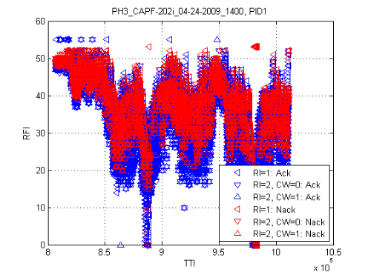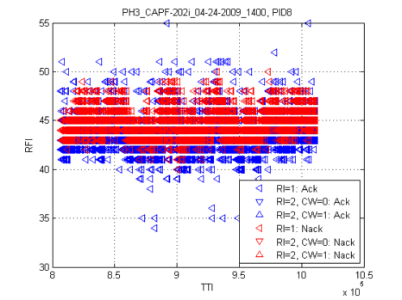
Figure 20 Used RFI per rank and codeword with indication of block error. Left figure: PID1 moving UE. Right figure: PID8 stationary UE.
For a moving UE, the outer loop adjustment seems to follow the slow fading of the channel as seen in Figure 21.
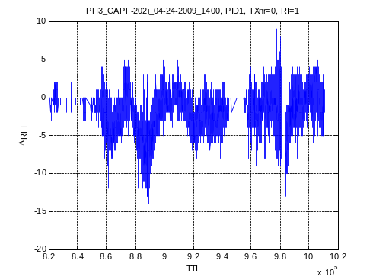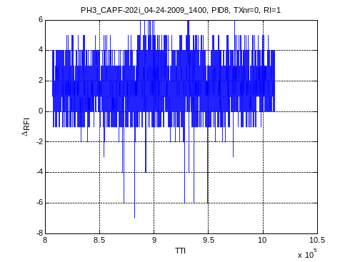
Figure 21 Outer loop adjustment in RFI scale versus time for 1st rank 1 transmission. Left figure: PID1 moving UE. Right figure: PID8 stationary UE.
If the channel quality estimation was “optimal”, the adjustment could be expected to vary “randomly” around 0. The reasons why the adjustment varies in a correlated manner like in Figure 21 (left) could be that the CQI value is biased differently in different SINR regions. (Figure 21 (right) shows an example of a stationary UE that has a CQI bias around 2). Furthermore, the skewed BLER phenomenon will contribute as well, by giving higher BLER when the channel degrades.
An example of the skewed BLER effect (see section 7.1) is shown in Figure 22 (left part of Figure 20 zoomed), where the channel makes a rapid and large shadow fading dip, starting around TTI = 880000. A concentration of BLER occurs when the channel quality falls (causing a fall in adjustment as well), and the opposite behavior when channel quality rises again.
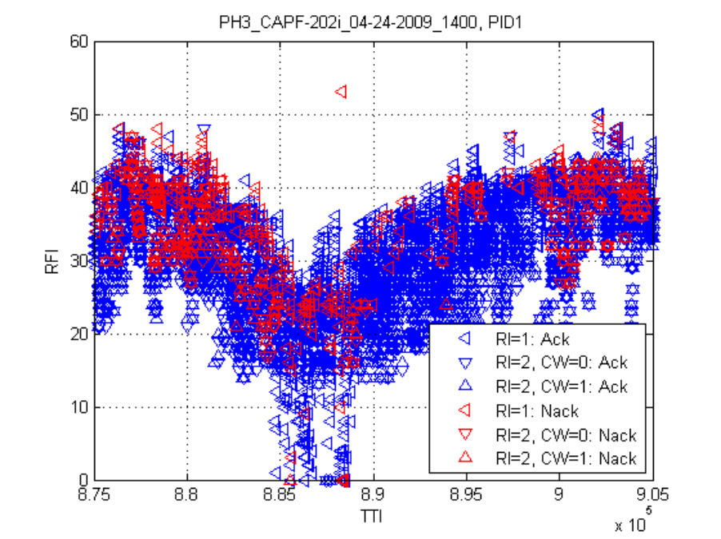
Figure 22 Higher BLER at degrading channel and lower BLER when the channel improves.
CQI bias and skewed BLER are two likely factors that make the adjustment reflect variations in shadow fading, rather than just showing unbiased “random” variations around 0.
Figure 23 shows that the outer loop tends to make negative adjustments at lower RFIs, both for the moving UE and the stationary UE. However, there is a distinct difference between the moving and stationary UE; for the moving UE, outer loop adjustment tends to be negative for the entire range of used RFIs, while for the stationary UE, the adjustment is positive for the higher used RFIs. This may be due to different bias in the channel quality estimation for different ranges of the SINR as mentioned previously. Note that a certain RFI on the x-axis in Figure 23 does not correspond to the same SINR/CQI, since the adjustment is different. It may also be due to that fading dips with increased BLER cause a relatively large negative adjustment that cannot be evened out by the smaller positive adjustment as the channel improves. This may lower the operating point for the outer loop adjustment for the moving UE compared to the stationary UE. As a result, performance can be negatively affected.
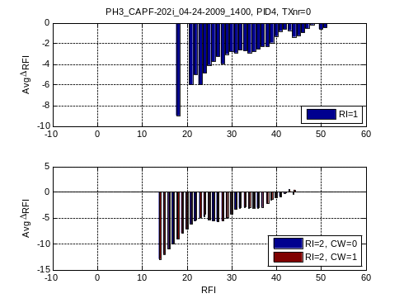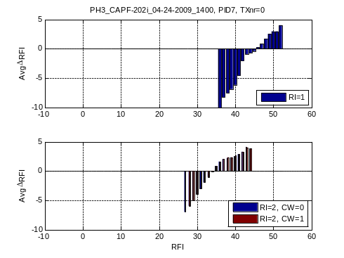
Figure 23 Average outer loop adjustment (rank 1 first transmission) in RFIs per used RFI. Left figures: PID4 moving UE. Right figures: PID7 stationary UE.

CQI adjustment per rank and codeword
The need for CQI adjustment per rank has been identified in tests using the 4x4 MIMO testbed [6]. In the FD0 testbed such rank-individual adjustment is implemented. For rank 2, the adjustment is implemented per codeword. In Figure 24 and Figure 25, examples of resulting adjustments are shown, for a moving UE with open-loop spatial multiplexing and a stationary UE with closed-loop spatial multiplexing respectively.
The figures show that the difference in adjustment per rank is large for both the stationary and the moving UE, 4 to10 RFI units correspond to 1 to 4 CQI units (see Table 2), or equivalently 2 to 8 dB. This verifies the need for CQI-adjustment per rank for both open-loop a closed-loop.

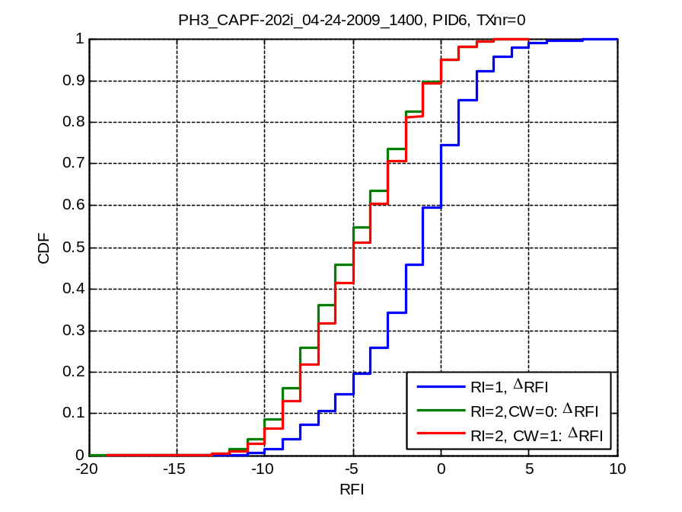
Figure 24 Rank-dependent outer loop adjustment. Open-loop spatial multiplexing. Moving UE.

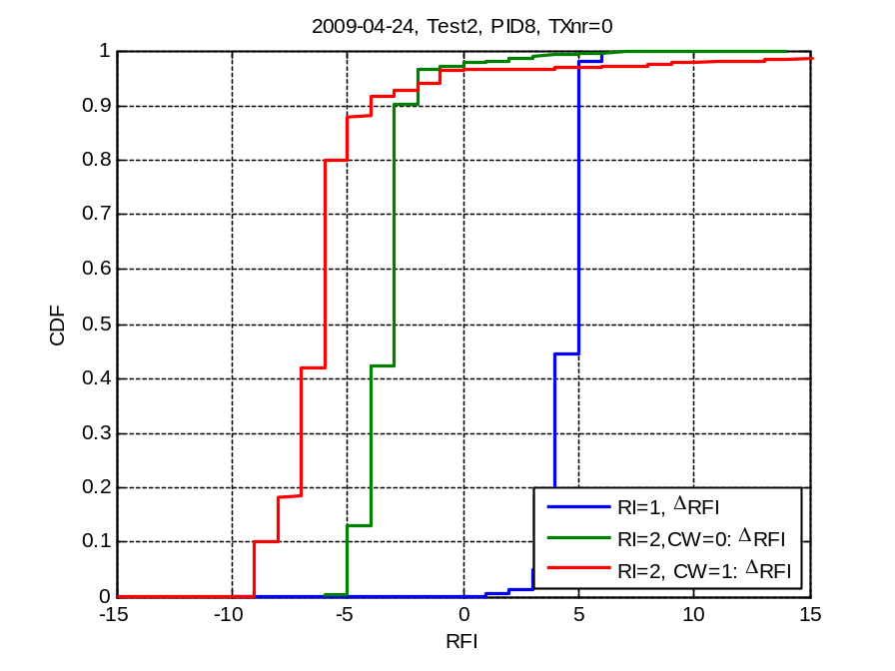
Figure 25 Rank- and codeword-dependent outer loop adjustment. Closed-loop spatial multiplexing Stationary UE.
CQI adjustment per rank can also be beneficial when selecting rank. Some rank switches have been observed where this can give a bit rate improvement since the currently used rank gets higher HARQ BLER than the other rank potentially would. This is an example where CQI estimation of non-reported rank would be useful. Alternatively, a measurement offset could be sent to the UE to adjust its rank selection.
The difference in CQI adjustment per codeword is small for the moving UE as seen in Figure 24. This is as expected for open-loop where the cyclic delay diversity should remove most of the codeword differences. For the stationary UE with closed-loop in Figure 25 it is larger, around 3 RFI units, but still significantly smaller than the difference compared to rank 1 adjustment. Larger differences between codewords have been observed, in Figure 3 around 6 RFI units difference is seen between the codewords.
As seen in Table 2, RFI is neither linearly related to CQI nor to the adjustment in dB. The absolute RFI distributions for the stationary UE are shown in Figure 26. For the rank 2 RFI-range, three RFI units correspond to one CQI unit or less, (approximately 2 dB adjustment difference or less). For the rank 1 RFI range the adjustment in RFI is larger in the CQI and SINR (dB) domains. So, the difference between rank adjustment and rank 2 codewords is actually larger than indicated in Figure 25. The gain from CQI-adjustment per codeword is clearly smaller than CQI-adjustment per rank. Thus, the studied case indicates less gain from codeword individual adjustment than from rank individual adjustment.
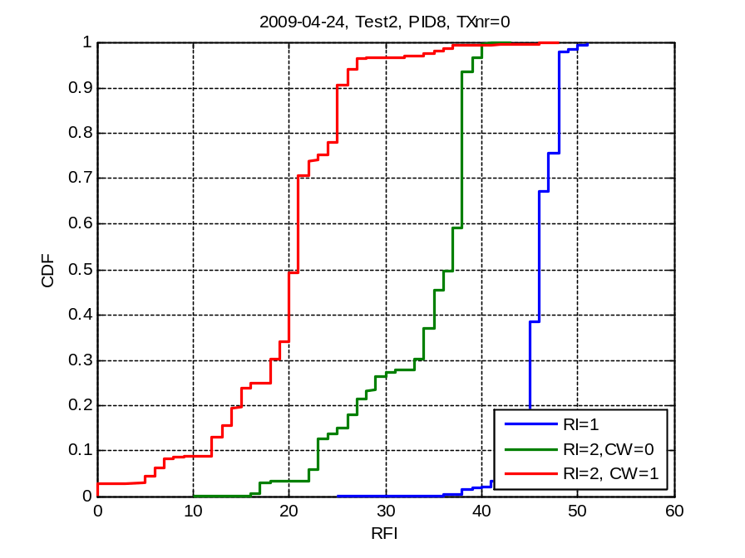
Figure 26 Used RFI distributions. Stationary UE

Conclusions
In the surrounding cell on-off interference test cases, observations show that a traditional CQI-adjustment targeting 10 % BLER fails to utilize the interference reduction achieved when lowering the load in surrounding cells. Performance is even worse in a 50 % load case compared to a 100 % load case, indicating that current LA algorithms are severely disturbed by pulsing interference, clearly indicating that current link adaptation algorithms are severely disturbed by pulsing interference, and need to be modified.
Observations show that the outer loop adjustment follows the shadow fading of the channel closely. The result is that CQI adjustment for mobile UEs gets displaced to purely negative adjustments, resulting in an overly conservative choice of format, and poorly utilized channel capacity. This further suggests studies on potential improvements of the outer loop adjustment algorithm.
CQI adjustment difference between ranks is significant both for open and closed loop spatial multiplexing. The difference between codewords for rank 2 closed-loop SM seems smaller. The need for rank specific CQI adjustment is more motivated than codeword specific adjustment.
The known HSDPA phenomenon with higher HARQ BLER for larger transport blocks is observed for LTE as well. Observations also show that the outer loop CQI-adjustment increases the effect, at least for stationary UEs.
Observations show that choice of reporting timing of CQI and RI reports on PUCCH were not beneficially chosen in the testbed, leading to unnecessary delay before rank change. This must be considered when choosing timing settings in the first product release.
The average CQI difference between rank 1 and rank 2 seem higher than the 1 dB assumed for HSPA. It is however unclear if this is due to LTE orthogonality properties, the testbed receiver performance, or simply if the analyzed statistics are insufficient. The found deviation is significant in dB scale but seems to result only in ± 1 CQI unit error, indicating that a fixed offset for PDCCH link adaptation based on rank 2 CQI could be feasible.
The testbed link adaptation implementation gives periodic increases in block error rate, caused by broadcast and synchronization (PBCH/PSCH/SSCH) signaling stealing robustness. A quick-fix resulted in reduced the impact of these problems, although they are still significant for some scenarios. It is important that proper consideration of PBCH/PSCH/SSCH is done already in the first product release.
Investigations of the age of used CQI values show that in general the age has little impact for test cases with shorter (5 ms) reporting interval. For moving UEs, a slight CQI aging effect was observed, and CQI adjustment reactions to these effects can potentially degrade performance unnecessarily. For larger reporting periods results were heavily affected by the periodic BLER artefact. However, in all the analyzed cases no suspicions of specific trends were raised. Currently, no major effects of CQI age were suspected even for larger reporting periods (up to 40 ms).

Further work
- The outer loop CQI adjustment algorithm has shown potential for improvement. For example it seems that with varying interference the current algorithm can not take advantage of radio quality peaks. Further analysis of the current algorithm and research on algorithm improvements should be investigated by system simulations with varying interference.
- Differences compared to HSPA regarding CQI dependence on rank, has been observed. This should be further investigated, for example by system simulations, to obtain knowledge of LTE inter-stream interference offset. Further studies in testbed logs to obtain more SINR statistics for inter-stream offsets can also contribute.
- There is an interest to study autocorrelation of CSI (CQI, RI, PMI) to see how these measures vary over time. This could then be used for comparisons with system simulator results, to see how well they match testbed results. Furthermore, this can give information on how filtering of these measures could and should be performed.
- During analysis of test logs in this study, performance differences between rank 2 code words (CW0 and CW1) have been observed. This should possibly be investigated further to understand why the differences occur.
- The CQI variation for a stationary UE seems to be smaller than observed for HSDPA [4]. One reason can be that the multi-path fading has less impact on the orthogonal LTE access. Analyzed test cases in this report, has a constant unchanged interference situation. With more realistic interference the variation will be increased. Further studies of CQI distributions and comparison between LTE and HSPA are therefore suggested.

References
- 3GPP TS 36.213, “E-UTRA Physical layer procedures (Release 8)”, V8.6.0 (2009-03)
- A. Simonsson, “CQI, BLER & TBS Measurement Analysis”, EAB-05:040777, rev. A.
- C. Tidestav, “Single-stream CQI estimation for HSPA MIMO”, EAB- 07:026361, rev. A.
- M. Maijala et al, “HSDPA performance – HSDPA and R99 on same carrier”, EAB/PD-06:0168, rev. A.
- A. Simonsson, “LTE test-bed performance vs CQI”, EAB-09:033250, rev. A.
- P. Svedman, “Ericsson Research LTE 4x4 MIMO Testbed:Link Adaptation”, Presentation at LEAD workshop 2008-10-08
- Association of Radio Industries and Businesses, Volume 3, Specifications of Air-Interface for 3G Mobile Systems, Ver. 1.0, January 1999.

Appendix

Transport formats in LTE testbed
Table 4 together with corresponding block size (TB) and corresponding code rate provides the mapping between TFI, RFI and CQI. TB size values, which are given in bits, depend on the control region size. The TB size includes 24-bit CRC and the number of bits available for the MAC layer is 24 bits smaller.

Table 4: TFI, RFI, CQI, TB sizes and code rates for the LTE testbed.
 |  |  |  | TB size |  |  | Code rate
 |  |  |  | 3 control symbol | 2 control symbols | 1 control symbols | 3 control symbol | 2 control symbols | 1 control symbols
 |  |  | #REs/PRB | 120 | 132 | 144 | 120 | 132 | 144
 |  |  | #PRBs | 50 | 50 | 50 | 50 | 50 | 50
TFI | RFI | CQI | Mod
0 | 0 |  | 2 | 824 | 952 | 1024 | 0.0687 | 0.0721 | 0.0711
1 | 1 | 1 | 2 | 888 | 1024 | 1096 | 0.0740 | 0.0776 | 0.0761
2 | 2 |  | 2 | 952 | 1096 | 1176 | 0.0793 | 0.0830 | 0.0817
3 | 3 |  | 2 | 1024 | 1176 | 1256 | 0.0853 | 0.0891 | 0.0872
4 | 4 |  | 2 | 1096 | 1256 | 1344 | 0.0913 | 0.0952 | 0.0933
5 | 5 |  | 2 | 1176 | 1344 | 1448 | 0.0980 | 0.1018 | 0.1006
6 | 6 |  | 2 | 1256 | 1448 | 1552 | 0.1047 | 0.1097 | 0.1078
7 | 7 |  | 2 | 1344 | 1552 | 1656 | 0.1120 | 0.1176 | 0.1150
8 | 8 | 2 | 2 | 1448 | 1656 | 1776 | 0.1207 | 0.1255 | 0.1233
9 | 9 |  | 2 | 1552 | 1776 | 1904 | 0.1293 | 0.1345 | 0.1322
10 | 10 |  | 2 | 1656 | 1904 | 2048 | 0.1380 | 0.1442 | 0.1422
11 | 11 |  | 2 | 1776 | 2048 | 2192 | 0.1480 | 0.1552 | 0.1522
12 | 12 |  | 2 | 1904 | 2192 | 2352 | 0.1587 | 0.1661 | 0.1633
13 | 13 |  | 2 | 2048 | 2352 | 2520 | 0.1707 | 0.1782 | 0.1750
14 | 14 | 3 | 2 | 2192 | 2520 | 2696 | 0.1827 | 0.1909 | 0.1872
15 | 15 |  | 2 | 2352 | 2696 | 2896 | 0.1960 | 0.2042 | 0.2011
16 | 16 |  | 2 | 2520 | 2896 | 3104 | 0.2100 | 0.2194 | 0.2156
17 | 17 |  | 2 | 2696 | 3104 | 3320 | 0.2247 | 0.2352 | 0.2306
18 | 18 |  | 2 | 2896 | 3320 | 3560 | 0.2413 | 0.2515 | 0.2472
19 | 19 |  | 2 | 3104 | 3560 | 3816 | 0.2587 | 0.2697 | 0.2650
20 | 20 |  | 2 | 3320 | 3816 | 4096 | 0.2767 | 0.2891 | 0.2844
21 | 21 | 4 | 2 | 3560 | 4096 | 4384 | 0.2967 | 0.3103 | 0.3044
22 | 22 |  | 2 | 3816 | 4384 | 4704 | 0.3180 | 0.3321 | 0.3267
23 | 23 |  | 2 | 4096 | 4704 | 5040 | 0.3413 | 0.3564 | 0.3500
24 | 24 |  | 2 | 4384 | 5040 | 5400 | 0.3653 | 0.3818 | 0.3750
25 | 25 |  | 2 | 4704 | 5400 | 5792 | 0.3920 | 0.4091 | 0.4022
26 | 26 |  | 2 | 5040 | 5792 | 6208 | 0.4200 | 0.4388 | 0.4311
27 | 27 | 5 | 2 | 5400 | 6208 | 6648 | 0.4500 | 0.4703 | 0.4617
28 | 28 |  | 2 | 5792 | 6648 | 7128 | 0.4827 | 0.5036 | 0.4950
29 | 29 |  | 2 | 6208 | 7128 | 7640 | 0.5173 | 0.5400 | 0.5306
30 | 30 |  | 2 | 6648 | 7640 | 8192 | 0.5540 | 0.5788 | 0.5689
31 | 31 | 6 | 2 | 7128 | 8192 | 8776 | 0.5940 | 0.6206 | 0.6094
32 | 32 |  | 2 | 7640 | 8776 | 9408 | 0.6367 | 0.6648 | 0.6533
33 | - |  | 2 | 8192 | 9408 | 10080 | 0.6827 | 0.7127 | 0.7000
34 | - |  | 2 | 8776 | 10080 | 10808 | 0.7313 | 0.7636 | 0.7506
35 | - |  | 2 | 9408 | 10808 | 11584 | 0.7840 | 0.8188 | 0.8044
36 | - |  | 2 | 10080 | 11584 | 12416 | 0.8400 | 0.8776 | 0.8622
37 | 33 |  | 4 | 8192 | 9408 | 10080 | 0.3413 | 0.3564 | 0.3500
38 | 34 | 7 | 4 | 8776 | 10080 | 10808 | 0.3657 | 0.3818 | 0.3753
39 | 35 |  | 4 | 9408 | 10808 | 11584 | 0.3920 | 0.4094 | 0.4022
40 | 36 |  | 4 | 10080 | 11584 | 12416 | 0.4200 | 0.4388 | 0.4311
41 | 37 |  | 4 | 10808 | 12416 | 13304 | 0.4503 | 0.4703 | 0.4619
42 | 38 | 8 | 4 | 11584 | 13304 | 14256 | 0.4827 | 0.5039 | 0.4950
43 | 39 |  | 4 | 12416 | 14256 | 15280 | 0.5173 | 0.5400 | 0.5306
44 | 40 |  | 4 | 13304 | 15280 | 16384 | 0.5543 | 0.5788 | 0.5689
45 | 41 | 9 | 4 | 14256 | 16384 | 17552 | 0.5940 | 0.6206 | 0.6094
46 | 42 |  | 4 | 15280 | 17552 | 18816 | 0.6367 | 0.6648 | 0.6533
47 | - |  | 4 | 16384 | 18816 | 20168 | 0.6827 | 0.7127 | 0.7003
48 | - |  | 4 | 17552 | 20168 | 21616 | 0.7313 | 0.7639 | 0.7506
49 | - |  | 4 | 18816 | 21616 | 23168 | 0.7840 | 0.8188 | 0.8044
50 | - |  | 4 | 20168 | 23168 | 24832 | 0.8403 | 0.8776 | 0.8622
51 | 43 | 10 | 6 | 16384 | 18816 | 20168 | 0.4551 | 0.4752 | 0.4669
52 | 44 |  | 6 | 17552 | 20168 | 21616 | 0.4876 | 0.5093 | 0.5004
53 | 45 |  | 6 | 18816 | 21616 | 23168 | 0.5227 | 0.5459 | 0.5363
54 | 46 | 11 | 6 | 20168 | 23168 | 24832 | 0.5602 | 0.5851 | 0.5748
55 | 47 |  | 6 | 21616 | 24832 | 26608 | 0.6004 | 0.6271 | 0.6159
56 | 48 | 12 | 6 | 23168 | 26608 | 28520 | 0.6436 | 0.6719 | 0.6602
57 | 49 |  | 6 | 24832 | 28520 | 30568 | 0.6898 | 0.7202 | 0.7076
58 | 50 | 13 | 6 | 26608 | 30568 | 32768 | 0.7391 | 0.7719 | 0.7585
59 | 51 |  | 6 | 28520 | 32768 | 35112 | 0.7922 | 0.8275 | 0.8128
60 | 52 | 14 | 6 | 30568 | 35112 | 37640 | 0.8491 | 0.8867 | 0.8713

Additional graphs from inter-cell interference tests
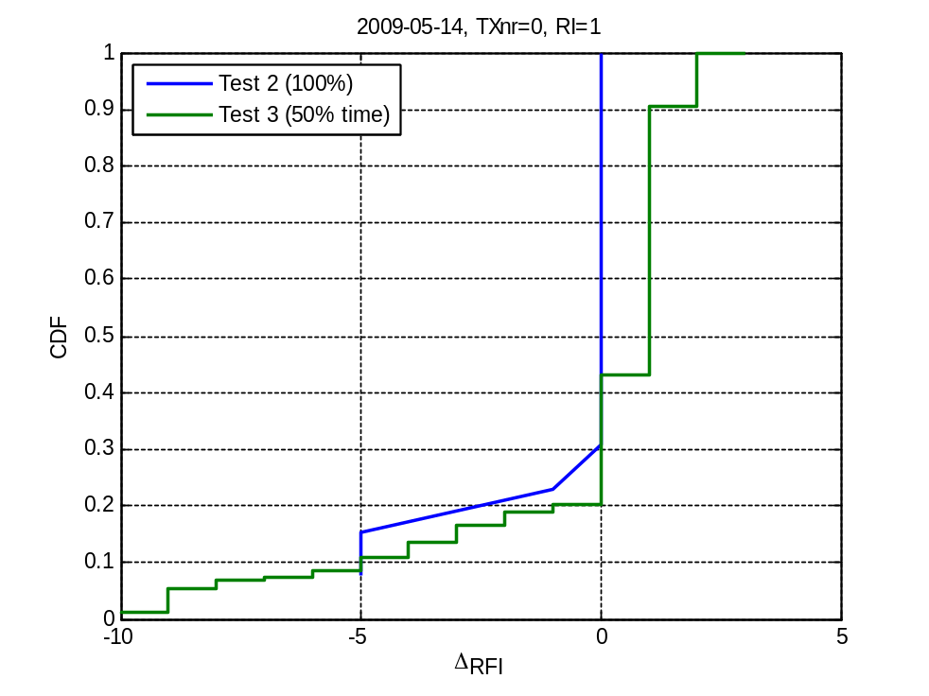
Figure 27 100 % load and 50 % load in time tests on 2009-05-14. CDFs of outer loop adjustment for first transmission attempt and rank one transmissions. Note: For Test 2 there is only 15 sampels.
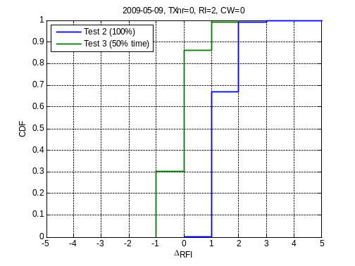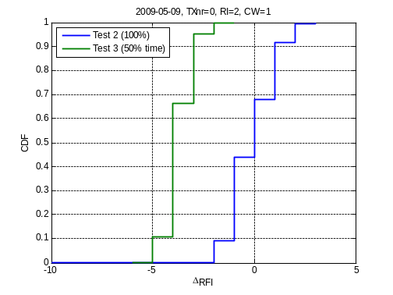
Figure 28 100 % load and 50 % load in time tests on 2009-05-09. CDFs of outer loop adjustment for first transmission attempt and rank two transmissions.
Left figure: CDF of outer loop adjustment in RFI scale for code word 0. Right figure: CDF of outer loop adjustment in RFI scale for code word 1.
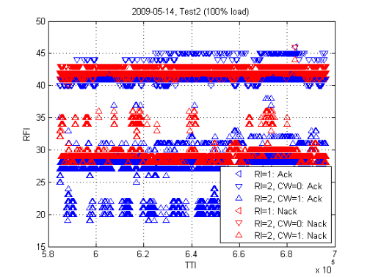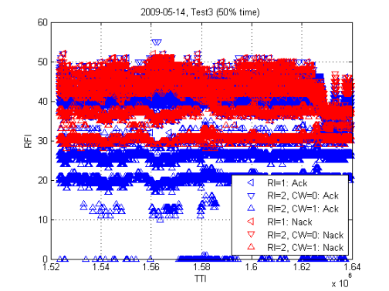
Figure 29 Used RFI per rank and codeword with indication of block error. Left figure: Test 2 (100% load). Right figure: Test 3 (50% time).
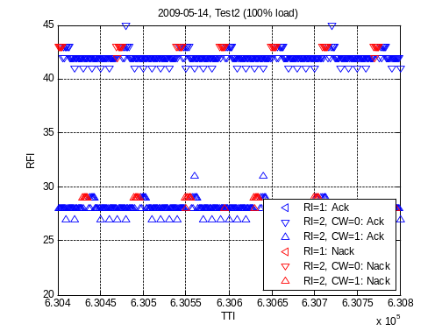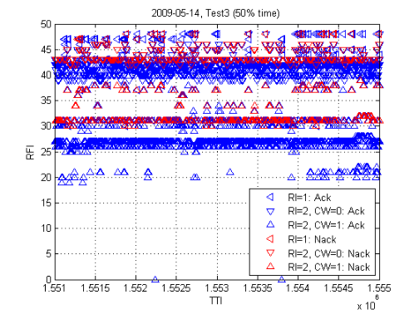
Figure 30 Used RFI per rank and codeword with indication of block error (Figure 29 zoomed). Left figure: Test 2 (100% load). Right figure: Test 3 (50% time).

The reason for the rather high reporting period was to reduce the load on PUCCH.
3GPP had not decided the number of bits to be used for the MCS signaling at the time the MCS signaling was specified for FD0.
When scheduled system information is transmitted, no ghostUE will be scheduled. The effect of this on the load value is neglected.
The tests were performed with same test setup, but with different software including a bug in the randomization function of the ghostUE function. The bug is however not believed to have any major impact on how the outer loop behaves.

